**Introduction**

* Ask them how many of them are Non-English & Non-Computer science background
* Introduce yourself
* Explain about your teaching style
* Ask them to be punctual about timings. Tell them If they make use of you they can learn many things like Design Patterns & Java Mail & even some of the Core Java topics etc
* Explain the importance of J2EE

FY2012 ====>  **2, 30, 000 IT jobs** opened (Excluding BPO / IT IS jobs) in India

VTU Intake Capacity ====> **208** colleges affiliated

67, 100 UG Students

12, 666 PG students

-------------

**79, 766 Total Students**

**70K Pass outs**

**50K Valid Job Aspirants**

So it means that **per college on an average** **240 Valid Job Aspirants get passed per year. Let make it as 200**

Total Number of Engineering colleges in India ===> 3, 380

So ( 3380 X 200 ) = 6, 76, 000 Valid Job Aspirants get passed per year in India

So even if we leave 1, 76, 000 there are **5, 00, 000** Valid Job Aspirants present across India which is double the number of openings in IT

**Along with Internal Competition, we are also facing the challenges of competitiveness in the globalized world, particularly from countries like China and Philippines.**

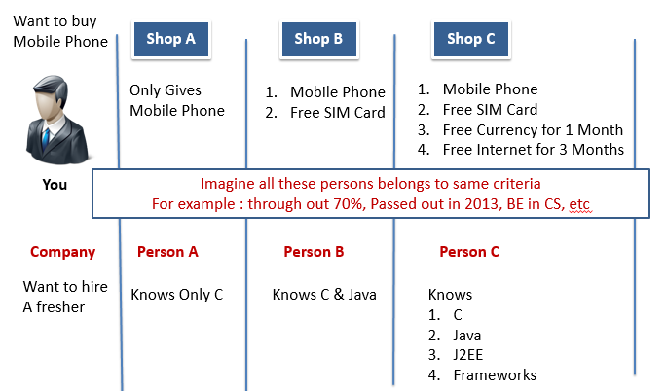

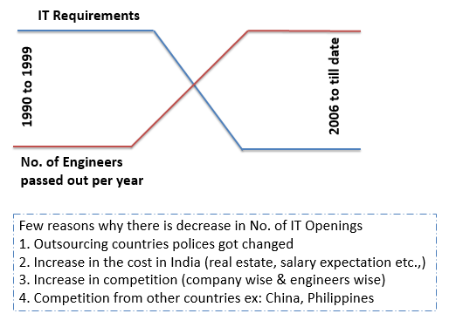

* Tell them about the 100% - 90% come to only getting the job. But if u know concepts then only u get the job.

|  |  |
| --- | --- |
|  | **Category 1:** These students are Proactive, Don’t miss the class, actively do the assignments & their intension is to get learn the concepts, clear the interview & get Job. **I need not worry about them. Because with right attitude they definitely reach to right level**  **Category 2:** These students join to institute with wrong intension (may be his / her BF / GF would have joined the institute ☺ or Parents would have forced them to join or may for some other reason). **I need not worry about them as well. Because their intension itself is wrong**  **Category 3:** These students join to institute just to get job. They think that if we join to this institute we get the job. **I am worried about this category. Their intension is right but there is approach is wrong** |

Probably someone who had done course here & got job would have told you that,

* **I joined this institute for j2ee course**
* This institute is really good with respect to staff & teachers
* Teachers helped to learn the concepts
* I also worked hard & did all the assignments
* That helped me to clear the interview
* **Hence I got the job**

But your mind catches the two things the first (joined the institute) & the last (got job) but forget the rest (i.e. learn & cleared the interview)

So you think, Join the institute & get a job. But actually it does not going to work like that. We (institute + teachers) helps you to get the necessary knowledge required to clear the interview & provides interview opportunities.

So to get a job you have to clear the interview, to clear the interview you have to learn the concepts & practise them & that helps you to get the job.

**Please Note: Just by joining to this institute & simply attending the course does not help you at all.**

**Links to prepare for Aptitude Test:**

[**http://www.kent.ac.uk/careers/tests/mathstest.htm**](http://www.kent.ac.uk/careers/tests/mathstest.htm)

[**http://www.indiabix.com/**](http://www.indiabix.com/)